Transect 1 GROUP

-Station Name

-Station Information

-Cross Section Location

-Comments with Measurements

-Drafts

- Declination

-Independent Water Temp

- Left Edge Shape

-Right Edge Shape

-Left Edge Distance

-Right Edge Distance

- Manual Speed of Sound

-Transect Identification

-Time of Day at start of transect

-Time elapsed or time of end of transect

-Mean velocity of boat

-Mean velocity of water

-Total Width

-Total Area

-System Test Results

- List of ensemble files

Moving Bed Test

Loop Test

Moving Bed Test

Stationary Method

**Discharge Measurement**

-Bottom Extrapolation

- Top Extrapolation

- Left and Right Extrapolation

-Measured/Estimate (top,bottom,right, left) discharge and total discharge

**Project 1**

-Date

-Serial Num

-Firmware Ver

-Draft of Transducer

-Magnetic Declination

-Software Ver

- Identification of crew

-Station Name and ID

-Water Temp

-Percentage of Discharge Measured

-Channel width

-Cross Sectional area

-Comments

Field Configuration

Playback Configuration

Site Information

Setup Dialog

* Site Information
* Rating Information
* Configuration Dialog
* Output Filename Options
* Commands Preview
* Summary Page

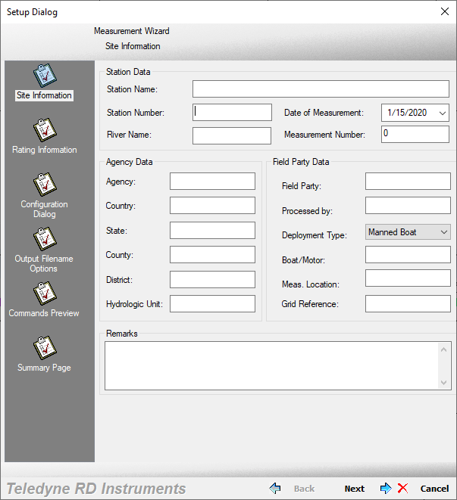 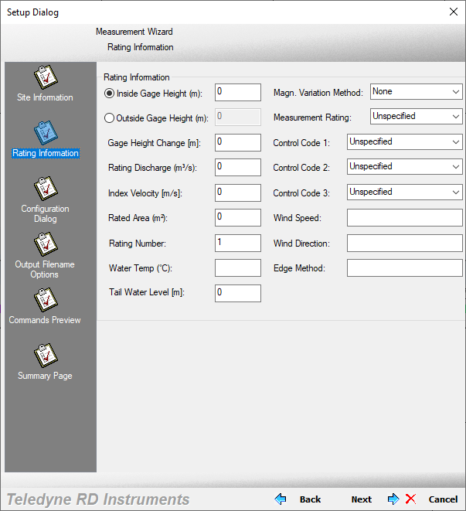

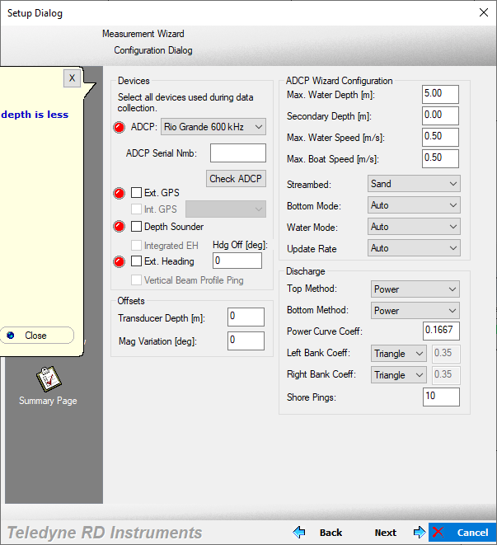 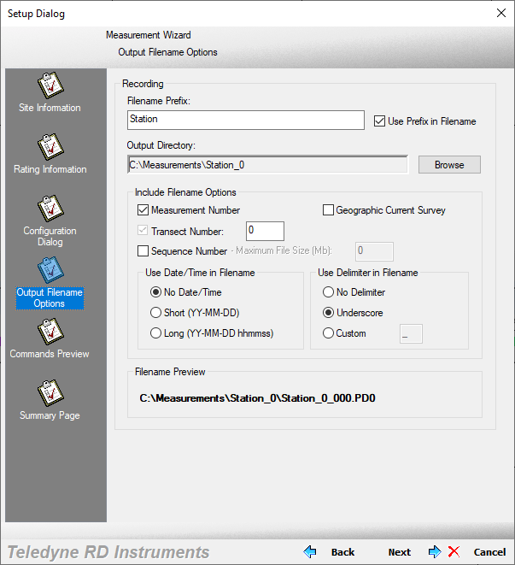

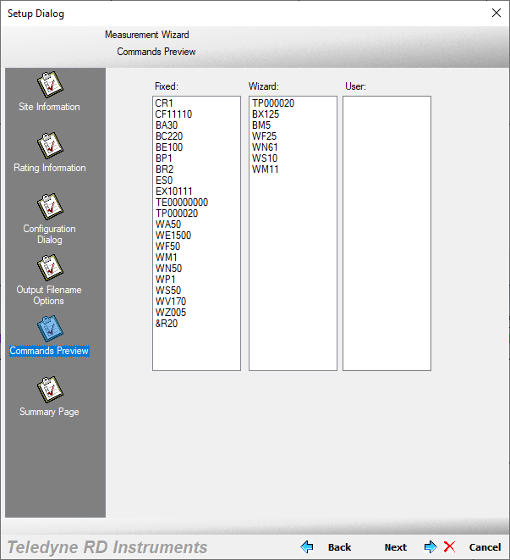 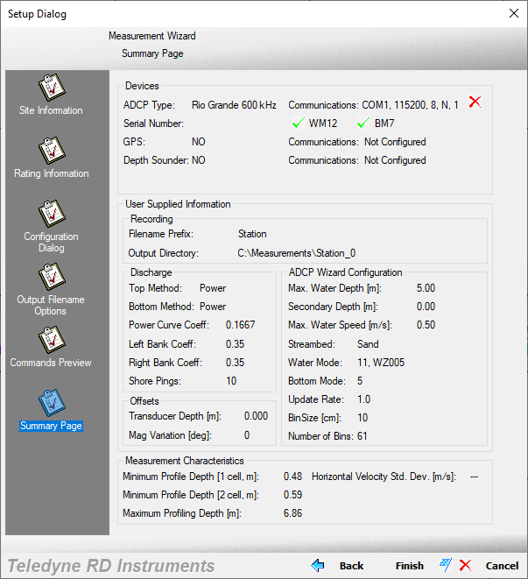

Site Information:

* Station Data
  + Station Name
  + Station Number
  + Date of Measurement
  + River Name
  + Measurement Number
* Agency Data
  + Agency
  + Country
  + State
  + County
  + District
  + Hydrologic Unit
* Field Party Data
  + Field Party
  + Processed By
  + Deployment Type (Boat type)
  + Boat/Motor
  + Measurement Location
  + Grid Reference
* Remarks
* Rating Information
  + Inside Gage Height
  + Output Gage Height
  + Gage Height Change
  + Rating Discharge
  + Index Velocity
  + Rated Area
  + Rating Number
  + Water Temp
  + Tail Water Level
  + Magn Variation Method
  + Measurement Rating
  + Control Code 1
  + Control Code 2
  + Control Code 3
  + Wind Speed
  + Wind Direction
  + Edge Method

Properties

* Commands
* Depth Sounder
  + Tranducer Depth
  + Offset
  + Scale Factor
  + Correct Speed of Sound
* External Heading
  + Heading Offset
  + Use External Heading
* GPS
  + Time Delay
  + Offset X
  + Offset Y
* Discharge
  + Parameters
    - Top Discharge Method
    - Bottom Discharge Method
    - Power Curve Coeff
  + Cut Water Profile Bins
    - Top Bins
    - Bins Above Sidelobe
  + Left Bank Edge Type
    - Trianglular (0.3535)
    - Square (0.91)
    - Coefficient
  + Right Bank Edge Type
    - Triangular (0.3535)
    - Square (0.91)
    - Coefficent
  + Shore Pings
* Edge Estimates
  + Begin Transect
    - Shore Distance
    - Left Bank/Right Bank
  + End Transect
    - Shore Distance
* Offsets
  + Adcp Transducer
    - Depth
  + Compass
    - Mag Variation
    - Beam 3 Misalignment
    - One Cycle K
    - One Cycle Offset
    - Two Cycle K
    - Two Cycle Offset
* Processing
  + Speed of Sound
    - Use ADCP Value
    - Calculate for Each Ping
      * Use Salinity
    - Fixed
  + Projection Angle (F2-Current)
  + Backscatter
    - Near-Zone Distance
    - Calculate for Each Ping
    - Used Fixed Value
      * Int. Scale
      * Absorption
  + River Depth Source
    - Bt Depth
    - Depth Sounder
    - Vertical Beam
    - Composite (VB)
    - Composite (BT)
  + Crossectional Area
    - Perpendicular to Mean Flow
    - Perpendicular to Proj Angle
    - Parallel to Average Course
  + Data Screening
    - Mark Below Bottom “Bad”
    - Mark Below Sidelobe “Bad”
    - Use 3 Beam Solution for BT
    - Use 3 Beam Solution for WT
    - Screen Depth
    - Use Weighted Mean Depth
    - Screen Depth Using BT Vel
  + Thresholds
    - BT Error Vel
    - WT Error Vel
    - BT Up Vel
    - WT Up Vel
    - Fish Intensity (255)
* Recording
  + File Name Prefix
    - Use Prefix in Filename
  + Output Directory
  + Include Filename Options
    - Measurement Number
    - Transect Number
    - Sequence Number
    - Geographic Current Survey
    - Maximum File Size
  + Use Date/Time in File Name
    - No Date/Time
    - Short (YY-MM-DD)
    - Long (YY-MM-DD hhmmss)
  + Use Delimiter in File Name
    - No Delimiter
    - Underscore
    - Custom
  + Record GPS data
  + Record Depth Sounder Data
  + Record External Heading Data

Configure Dialog

* Devices
  + ADCP
    - Adcp Serial Number
    - Check ADCP
  + Ext GPS
  + Int GPS
  + Depth Sounder
  + Integrated EH
  + Ext Heading
    - Heading Offset
  + Vertical Beam Profile Ping
* Offsets
  + Transducer Depth (0.08)
  + Mag Variation
* ADCP Wizard Configuration
  + Max Water Depth
  + Secondary Depth
  + Max Water Speed
  + Max Boat Speed
  + Streambed
  + Bottom Mode
  + Water Mode
  + Update Rate